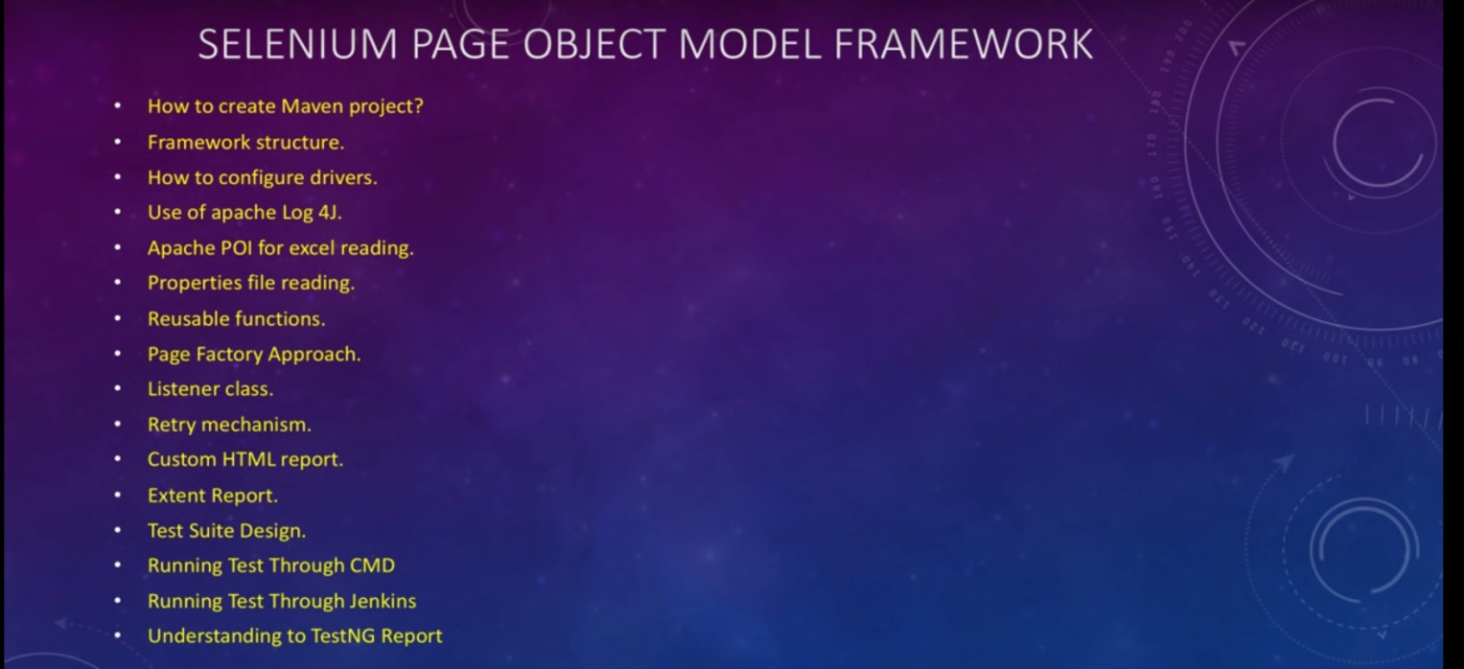

**While creating a maven project.**

Group id is the package name

Artifact id is the project name

For selenium driver-<http://www.seleniumhq.org/download/>

For latest firefox driver- <https://github.com/mozilla/geckodriver/releases>

For chrome driver- <https://sites.google.com/a/chromium.org/chromedriver/>